SAP COE Technical Specification | Unique Identifier | 240-114883091
SAP COE Technical Specification | Revision No. | 3
SAP COE Technical Specification | Revision Date | April 2022
SAP COE Technical Specification | Effective Date | April 2021
SAP COE Technical Specification | Total Pages | 7

<Solution Name>
PART 1 : Service Communication Information Exchange, NT Service
<Request Control Reference Number/Project WBS>
<From to Direction>

Table Contents
List of Abbreviations and Definitions 3
1 Introduction 3
1.1 Background 3
1.2 Scope 3
1.3 Relevant Business Units 3
1.4 List of Architecturally Relevant Documents 3
2 Business Architecture or Requirements 4
2.1 Functional Overview 4
2.2 Assumptions/Business Rules 4
2.3 References 4
2.4 Systems Flow Diagram/Integration Architecture 4
2.5 Impacted Processes, Systems, Packages/Applications 4
2.6 Overall function’s triggering 4
2.7 Overall function’s frequency 4
3 Technical Architecture 5
3.1 Development Object Specifications 5
3.2 Development Object Design and components 5
3.3 Development Object Program Logic Flow 5
3.4 Development Object Pseudo Code 5
3.5 Development Object Error Handling 5
4 Data Layout Requirements 5
5 Operations Specifications 6
5.1 Security/ Authorization requirements 6
5.2 Job Scheduling requirements 6
5.3 System recoverability requirements 6
6 Testing Guidelines 6
7 Risks 6
8 Signoff as applicable 7

List of Abbreviations and Definitions
Abbreviation | Description
ABAP | Advanced Business Application Programming
SAP | Systems, Applications & Products in Data Processing
SAP PO | Process Orchestration
XML | Extensible Markup Language
XSD | XML Schema Definition
XSLT | Extensible Stylesheet Language Transformations
WSDL | Web Services Description Language
SOA | Service-Oriented Architecture

Introduction

Background
The technical specification defines the detailed design requirements of the solution. This is where the data models, processes, classes, data flows, methods and variables are described. For each function, the technical specification describes how it will be carried out, what parameters are required, what the data mapping is, what cases need to be tested, implemented monitoring, audit detail and how any errors and data quality issues should be handled.
The purpose of the Technical Specification is to define the technical implementation details to such a level that the document can be handed to a developer to execute.
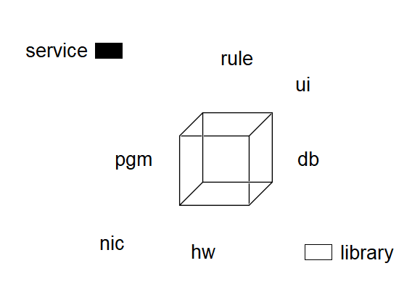

Scope
Define the responsibility and deliverables covered by this project stating clearly what is expected from the developers in order to deliver the designed solution.
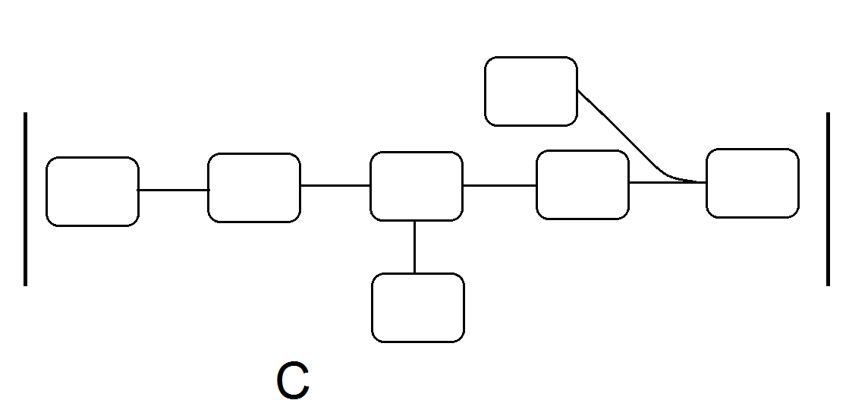

Relevant Business Units
The following questions can assist you to focus on relevant issues (taking into consideration that earlier stages contain less detail which is added during latter stages):
- Which department is/are responsible for the project?
- Are there any other department(s) participating in the project or foreseen to be using the product/services that will be created by the project?
- Have you completed the index of architecturally relevant deliverables?

Department | Contact person | Role | Contact Details

List of Architecturally Relevant Documents
Document Name | Revision | Publishing Agency | Location

Business Architecture or Requirements

Functional Overview
Give a general description of the business requirement for this development object.
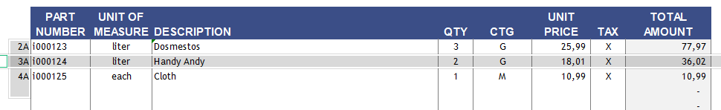

Assumptions/Business Rules
List all assumptions or business rules that impact this development

References
List all documents to be referred for this technical spec.

Systems Flow Diagram/Integration Architecture
In case of an interface development, a system flow diagram can also be given here to represent the data flow between the systems.

Impacted Processes, Systems, Packages/Applications
List all impacted processes, systems and applications.
SAP Modules Impacted
Other Systems Impacted
Other Applications Impacted

Overall function’s triggering
List how the function is triggered. E.g. by the user, a event, an external system or at a certain time.
For SAP user-exits state the transaction and the activity (e.g. at save) when user-exit is invoked.

Overall function’s frequency
How many users (on average) will use this function? How often is the function started during the month?
How often is the function started during month-end work? Note: Use in your calculation (number of users) * (times per day/month)

Technical Architecture
In case of interface development, both sending and receiving system should provide the details. Section 4.2 should be repeated for both the systems and should also include any middleware object development.

Development Object Specifications
Development objects are logical objects, which can be SAP programs, Functional Modules, Business Subjects, Processes, Interfaces, etc (depending on the system for which the spec is being written).

Development Object Design and components
Record properties of data, fields, and look/feel elements as needed.
Inputs
List all input requirements for this development. It could be selection-screen, custom screen, variant, and file (A detailed data-layout should be described in section 4). In case of selection-screen, list the field type, length, default values, mandatory, range or single value etc.
Outputs
List all output requirements for this development. It could be a report, file (A detailed data-layout should be described in section 4). For report layout, use appendix A.

Development Object Program Logic Flow
This flow diagram of the logic in the program should be at a level of detail that it describes the program and/or information flow that will be implemented with this new development. The detail of the flow diagram(s) should be determined by the complexity of the development.

Development Object Pseudo Code
This section will list the Pseudo code for the development object. Describe any specific processing logic required for this to conform to the business requirements. This will include specific criteria and/or formulas to be used in the processing. This includes the calculation and/or presentation of totals. The section should also contain the description of the data sorting criteria if applicable.

Development Object Error Handling
This section will describe how the functional error handling requirements will be met. List all the exception conditions raised within the program including cause and action to be taken.

Data Layout Requirements
This section will be used for interface development both inbound and outbound. In case of IDOC development, list segments, fields, high-level segment, occurrence etc. Repeat the layout section for header and item specific layout.

Operations Specifications

List the operational requirements like specific security/authorization requirements ( Who (which user-roles) should execute it? Should this be executed in batch or on-line? Any special authorization requirement within the development objects like authority-check etc.?), Scheduling requirements (job name, frequency, dependencies etc) and system recoverability requirements.

Security/ Authorization requirements
Object name could be program name, transaction code, directory and file name etc.
Object Name | Auth. Group | Remarks

Job Scheduling requirements
List the job frequency, timing, triggers, job dependencies and conflicts.

Job Name | Frequency | Timing | Dependencies | Variant | Est. Volume | Remarks

System recoverability requirements
During the execution a job could fail for various reasons. Describe the various points of job failure and associated recovery procedure like if the job fails then it can be retriggered or it should not be triggered (will create duplicate records issue).

Testing Guidelines
At this stage, describe the testing requirements within the following categories:
- Unit Testing (Minimum requirement of the technical specification is to list each test case with a description)
- Integration Testing
- User Acceptance Testing
- Negative Testing
- Performance Testing
- Regression Testing
- Automated Testing

Risks
Identify and list the Technical risks and then determine a strategy to address them.
Name Risk ID | Risk | Effect | Sign Frequency | Impact

Signoff as applicable
Role | Name | Date | Signature
Developer 1
Developer 2
Systems Analyst
*Development Manager/Team lead
*Integration Architect
*Project Manager
*Program Manager
*Release Manager
*Remove ones not applicable

